**Bug on Page ‘my.bonify.de’:**

**Issues 11:**

Left hand side menu starts with small letter.

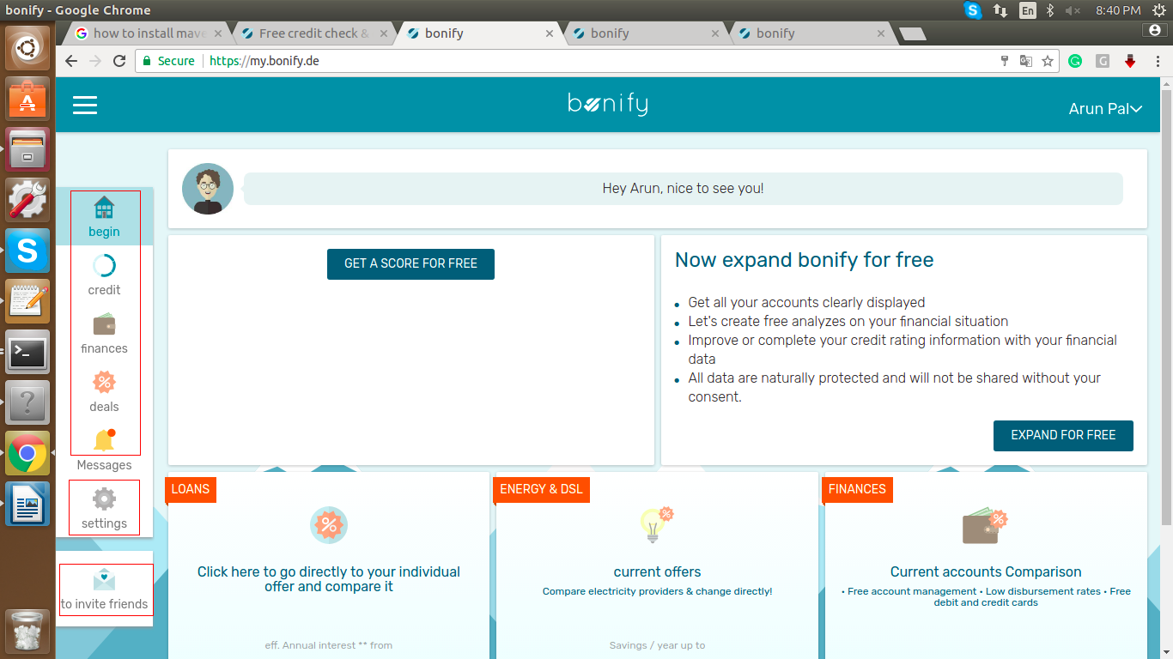

**Steps To Reproduce:**

1: Login with Register User.

2: After login verify Left Menu items, ‘begin’, ‘credit’, ‘finances’, ‘deals’, ‘setting’ and ‘to invite friends’ all are starting with small letter.

**Expected Result:** Left Menu items should start with capital letter.

**Actual Result:** Left Menu items should start with small letter except ‘Messages’.

**Browser:** Chrome (Version 70)

**OS:** Ubuntu (16)

**Priority:** P1

**Assign To :** Developer.